Fast**National University of Computer & Emerging Sciences, Karachi  
Fall-2018 CS-Department  
MidTerm 1   
5th October, 2018, 11:00 am – 12:00 pm**

|  |  |
| --- | --- |
| **Course Code: CS 203** | **Course Name: Database Systems** |
| **Instructor Name: Dr. Zulfiqar Ali Memon/Mr. Shoaib Rauf/Ms. Anam Qureshi** | |
| **Student Roll No:** | **Section:** |

Instructions:

* Return the question paper. Don’t write anything on question paper, except your Roll # & Section #.
* Read each question completely before answering it. There are **7 questions and 2 pages.**
* In case of any ambiguity, you may make assumptions. But your assumptions should not contradict any statement in the question paper.
* All the answers must be solved according to the sequence given in the question paper.
* This paper is subjective. Write the answers only on answer sheet.

**Time**: 60 minutes. **Max Marks**: 15

**Question 1:** Consider the following Database schema: [4 marks]

Company (name, city, country)

Dancer (did, name, birthyear, country)

Show (sid, title, choreographer, composer, year)

Role (did, sid, role, company)

Where,

* *Company* stores information about dance companies. The attributes *name, city,* and *country* are all string; we assume that all companies have unique names.
* *Dancer* stores information about individual dancers. *did* is a unique integer id for each dancer. *name* is a string with the dancer’s name, *birthyear* is an integer, and the dancer’s native *country* is a string.
* *Show* stores information about ballet shows (dances). Each show has a unique integer id *sid,* string attributes for the show *title, choreographer,* and *composer*, and an integer *year* in which the show was created.
* *Role* stores information about which dancers have been in which shows, the name of the role (part) they danced, and the company where they danced that part in that particular show. The dancer and show id’s are integers, the *role* and *company* names are strings. A dancer may have danced multiple roles in the same show at the same company, or danced the same role in the same show for different companies, and so forth.
* Several attributes in *Role* are foreign keys: *did* references *did* in *Dancer*, *sid* references *sid* in *Show*, and *company* references *name* in *Company.*

Write the SQL queries for each of the following:

1. Write the CREATE TABLE command needed to create the *Dancer* and *Role* tables.
2. Write the SELECT query to show, for every dancer who has performed the role ‘Black Swan’ in the show ‘Swan lake’ for one or more companies, list the name of the dancer and the company name(s), sorted by dancer name. If the dancer has performed that role for more than one company, there should be one line of output for each dancer, company pair. The companies can be listed in any order.
3. Write the SELECT query to List the dancer ids (did) and names of all dancers born on or before 1950 and who have danced in at least three different shows. If a dancer has danced different roles in the same show, it still only counts once in the total number of shows. Each dancer/did pair should only be listed once.
4. Write the SELECT query to show, for every dancer who has danced for one or more companies in a different country than where they were born, list the name of the dancer and the names of those companies.

**Question 2:** Compare and contrast the two-tier client-server architecture for traditional DBMSs with the three-tier client-server architecture. Why is the three-tier architecture more appropriate for the Web? [1.5 marks]

**Question 3:** Define Data, Information, Database, DBMS and Database System? [2 marks]

**Question 4:** In some small organization with 200 employees’, attendance is collected daily through hand punch machines, which is then collected by HR department on monthly basis to generate salaries. Once salaries for a month have been drawn, the monthly attendance is of no more use for that small organization and therefore flushed (deleted). Identify the main concerns (drawbacks) of this system and discuss whether or not it will be beneficial to go for DBMS in the light of these concerns. [1.5 marks]

**Question 5:** Unilever Pakistan maintains their record of Products sale in File Based System at Regional Offices. Now they want to develop a Mobile App to monitor the production and to compete the demand and supply issue in market for their products. Briefly explain how the DBMS will prove beneficial with respect to their business demands, also discuss the issue(s) in their current record keeping system? [1.5 marks]

**Question 6:** Carefully study the following database schema of Hotel Management System:

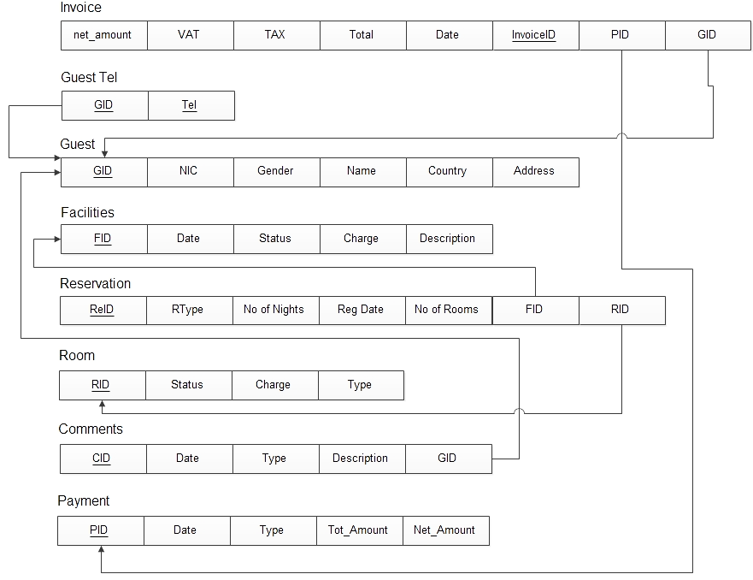

NOTE: The possible values (domain) for the RType attribute in the Reservation table are: (1, 2, 3), where 1 means Pending, 2 means Guaranteed, and 3 means cancelled. [3 marks]

Answer the following questions, in the order specified:

1. Write an SQL statement to add a new attribute named *GID* in the Reservation table, and create it as foreign key constraint to refer to GID attribute in the Guest table, so that every reservation should hold a guest ID.
2. After adding a new attribute as in part (a) above, now Insert a new record with the following values in the reservation table: *(R-123, 1, 2, 29-09-2018, 1, NULL, R-109, G123)*
3. List all the possible integrity constraint violations which may occur during the insert operation in part (b) above.

**Question 7:** Describe the relationship between mathematical relations and relations in the relational data model?

[1.5 marks]

Good Luck